

**ONLINE CHATBOT FOR**

**MUSEUM TICKET BOOKING**

**A PROJECT REPORT**

***Submitted by***

PRAKRUTHI K - 20221CSE0474

NEHA G - 20221CSE0375

R SANJAY - 20221CSE0410

### *Under the guidance of,*

**Dr.Malepati Chandra Shekhar**

**BACHELOR OF TECHNOLOGY**

**IN**

**COMPUTER SCIENCE AND ENGINEERING**

**PRESIDENCY UNIVERSITY**

**BENGALURU**

**DECEMBER 2025**



**PRESIDENCY SCHOOL OF COMPUTER SCIENCE AND**

**ENGINEERING**

**BONAFIDE CERTIFICATE**

Certified that this report **“**ONLINE CHATBOT FOR MUSEUM TICKET BOOKING**”** is a bonafide work of PRAKRUTHI K(20221CSE0474), NEHA G(20221CSE0375) , R SANJAY (20221CSE0410) , who have successfully carried out the project work and submitted the report for partial fulfilment of the requirements for the award of the degree of BACHELOR OF TECHNOLOGY in COMPUTER SCIENCE AND ENGINEERING, during 2025-26.

|  |  |  |  |
| --- | --- | --- | --- |
| **Mr. Wasim Yasin**  Project Guide  PSCS  Presidency University | **Dr. Jayavadivel R**  Program Project  Coordinator  PSCS  Presidency University | **Dr. Sampath A K**  School Project  Coordinators  PSCS  Presidency University | **Dr. Asif Mohammed**  Head of the Department  PSCS  Presidency University |
| **Dr. Shakkeera L**  Associate Dean  PSCS  Presidency University |  |  | **Dr. Duraipandian N**  Dean  PSCS & PSIS  Presidency University |

**Examiners**

|  |  |  |  |
| --- | --- | --- | --- |
| **S. No** | **Name** | **Signature** | **Date** |
|  |  |  |  |
|  |  |  |  |

**PRESIDENCY UNIVERSITY**

**PRESIDENCY SCHOOL OF COMPUTER SCIENCE AND ENGINEERING**

DECLARATION

We the students of final year B.Tech in COMPUTER SCIENCE ENGINEERING, at Presidency University, Bengaluru, named Prakruthi K, Neha G, R Sanjay, hereby declare that the project work titled **“Online chatbot based museum ticketing system”** has been independently carried out by us and submitted in partial fulfillment for the award of the degree of B.Tech in COMPUTER SCIENCE ENGINEERING during the academic year of 2025-26. Further, the matter embodied in the project has not been submitted previously by anybody for the award of any Degree or Diploma to any other institution.

Prakruthi K USN: 20221CSE0474

Neha G USN: 20221CSE0375

R Sanjaay USN: 20221CSE0410

PLACE : BENGALURU

DATE : 3rd December, 2025

ACKNOWLEDGEMENT

For completing this project work, We/I have received the support and the guidance from many people whom I would like to mention with deep sense of gratitude and indebtedness. We extend our gratitude to our beloved **Chancellor, Pro-Vice Chancellor, and Registrar** for their support and encouragement in completion of the project.

For completing this project work, We/I have received the support and the guidance from many people whom I would like to mention with deep sense of gratitude and indebtedness. We extend our gratitude to our beloved **Chancellor, Pro-Vice Chancellor, and Registrar** for their support and encouragement in completion of the project.

I would like to sincerely thank my internal guide **Dr.Malepati Chandra Shekhar,** Presidency School of Computer Science and Engineering, Presidency University, for his moral support, motivation, timely guidance and encouragement provided to us during the period of our project work.

I am also thankful to **Dr. Blessed Prince, Professor, Head of the Department, Presidency School of Computer Science and Engineering** Presidency University, for his mentorship and encouragement.

We express our cordial thanks to **Dr. Duraipandian N**, Dean PSCS & PSIS, **Dr. Shakkeera L**, Associate Dean, Presidency School of computer Science and Engineering and the Management of Presidency University for providing the required facilities and intellectually stimulating environment that aided in the completion of my project work.

We are grateful to **Dr. Sampath A K, and Dr. Geetha A, PSCS** Project Coordinators**, Jayavadivel R, Program Project Coordinator**, Presidency School of Computer Science and Engineering, or facilitating problem statements, coordinating reviews, monitoring progress, and providing their valuable support and guidance.

We are also grateful to Teaching and Non-Teaching staff of Presidency School of Computer Science and Engineering and also staff from other departments who have extended their valuable help and cooperation.

PRAKRUTHI K

NEHA G

R SANJAY

Abstract

Museums are key places that help keep culture alive and offer people chances to learn. But the old ways of booking tickets—like using counters or static websites—can be slow, hard to use, and don’t support many languages, which can turn people away. As AI becomes more common in customer service, chatbots are a great way to make the ticket booking process easier and better for visitors.

This project is about creating an AI-powered chatbot for booking museum tickets online.

The chatbot uses Natural Language Processing (NLP) to talk to users in a way that feels natural and easy to understand, making it simple for both local and international visitors. The solution includes parts that handle user conversations, figure out what the user wants, manage a database, handle online payments securely, and create tickets using QR codes. In addition to booking tickets, the chatbot can also share information about the museum, like opening hours, exhibitions, and events, acting like a helpful virtual assistant.

The system is built using open-source tools like Rasa or Dialogflow for the chatbot and Flask or Django for the back-end.

Secure payment systems are included through APIs, and the chatbot is hosted on the cloud to make it scalable and dependable. The design also keeps costs low, so it works well for museums of all sizes and visitor numbers.

The outcome shows that this chatbot offers a quicker, easier, and more convenient way to book tickets compared to traditional methods.

Users can buy tickets right away, get instant confirmations, and get digital tickets through QR codes, which reduces the need for paper tickets. Overall, this AI chatbot helps visitors have a better experience, makes museum work more efficient, and brings ticket booking into the modern digital age.

Table of Content

|  |  |  |
| --- | --- | --- |
| **Sl. No.** | **Title** | **Page No.** |
|  | Declaration | i |
|  | Acknowledgement | ii |
|  | Abstract | iii |
|  | List of Figures | vi |
|  | List of Tables | vii |
|  | Abbreviations | viii |
| 1. | Introduction  1.1 Background  1.2 Statistics of project  1.3 Prior existing technologies  1.4 Proposed approach  1.5 Objectives  1.6 SDGs  1.7 Overview of project report | 1 |
| 2. | Literature review | 7 |
| 3. | Methodology | 12 |
| 4. | Project management  4.1 Project timeline  4.2 Risk analysis  4.3 Project budget | 17 |
| 5. | Analysis and Design  5.1 Requirements  5.2 Block Diagram  5.3 System Flow Chat | 20 |
| 6. | Hardware, Software and Simulation | 26 |
| 7. | Evaluation and Results | 30 |
| 8. | Social, Legal, Ethical, Sustainability, and Safety Aspects | 38 |
| 9. | Conclusion | 40 |
| 10. | References | 42 |

# **LIST OF FIGURES**

| **Fig. No.** | **Caption** | **Page No.** |
| --- | --- | --- |
| **Fig 1.1** | Sustainable Development Goals (SDGs) | 7 |
| **Fig 3.1** | The V-Model Methodology for System Development | 12 |
| **Fig 5.2** | Functional Block Diagram of the Online Chatbot Ticketing System | 18 |
| **Fig 5.3** | System Flow Chart of the Chatbot-Based Ticketing System | 19 |
| **Fig 5.4** | Use Case Diagram for Museum Ticket Booking | 20 |
| **Fig 6.1** | System Architecture (Interface + Logic + Payment Layers) | 22 |
| **Fig 6.2** | User Interface Layout Overview (Chat Window + Sidebar) | 23 |
| **Fig 7.1** | Sample Unit Testing Workflow | 26 |
| **Fig 7.2** | Integration Testing Sequence | 27 |
| **Fig 7.3** | System Testing End-to-End Booking Flow | 29 |
| **Fig 8.1** | SLENS (Social–Legal–Ethical–Sustainability) Impact Framework | 32 |

# **LIST OF TABLES**

| **Table No.** | **Caption** | **Page No.** |
| --- | --- | --- |
| **Table 2.1** | Summary of Literature Reviews | 10 |
| **Table 4.1** | Project Planning Timeline | 14 |
| **Table 4.2** | Project Implementation Timeline | 15 |
| **Table 4.3** | PESTEL Risk Analysis | 16 |
| **Table 5.1** | Summary of System Requirements | 17 |
| **Table 6.1** | Minimum Hardware Requirements | 21 |
| **Table 6.2** | Recommended Hardware Specifications | 21 |
| **Table 6.3** | Software Requirements | 22 |
| **Table 7.1** | Unit Testing Cases and Results | 25 |
| **Table 7.2** | Performance Evaluation Metrics | 30 |

# **LIST OF ABBREVIATIONS**

| **Abbreviation** | **Full Form** |
| --- | --- |
| **AI** | Artificial Intelligence |
| **NLP** | Natural Language Processing |
| **UI** | User Interface |
| **UX** | User Experience |
| **UAT** | User Acceptance Testing |
| **API** | Application Programming Interface |
| **SDG** | Sustainable Development Goal |
| **QR** | Quick Response (Code) |
| **DB** | Database |
| **CPU** | Central Processing Unit |
| **RAM** | Random Access Memory |
| **HTML** | HyperText Markup Language |
| **CSS** | Cascading Style Sheets |
| **JS** | JavaScript |
| **SSL/TLS** | Secure Socket Layer / Transport Layer Security |
| **CRM** | Customer Relationship Management |

Chapter 1

Introduction

Museums serve as custodians of cultural heritage and centers for public education, yet they face the ongoing challenge of adapting to the demands of a digitally connected world. Traditional ticketing methods—typically reliant on physical counters, telephone reservations, or standard online forms—often lead to inefficiencies such as long wait times, booking errors, and limited accessibility for international or tech-savvy visitors. As attendance numbers rebound post-pandemic and competition for audience engagement intensifies, museums must leverage technology to enhance operational efficiency and visitor satisfaction. The emergence of artificial intelligence (AI), particularly conversational AI in the form of chatbots, presents a promising solution for the transformative modernization of museum operations. This paper advocates for an online chatbot-based ticketing system as an innovative approach to revolutionize how museums handle visitor bookings and interactions. By integrating a natural language processing (NLP)-powered chatbot into their online platforms, museums can offer a seamless, user-friendly experience for purchasing tickets, selecting visit times, and accessing exhibit-related information. Unlike traditional systems, this approach operates around the clock, supports multiple languages, and provides real-time updates, making it adaptable and scalable to accommodate diverse visitor needs. Furthermore, the chatbot's data collection and analysis features equip museum administrators with valuable insights for strategic planning and resource optimization.

The proposed system not only addresses operational challenges but also enhances the visitor experience by transforming ticketing into an interactive and engaging process. From alleviating staff burdens to catering to a global audience, the benefits of such a system are extensive. This introduction sets the stage for a comprehensive analysis of the chatbot-based ticketing system, including its design and implementation considerations as well as its future implications for the museum sector.

1.1 Background

The use of Artificial Intelligence (AI) in customer service and automation has significantly expanded in the last decade, particularly through the deployment of chatbots. Chatbots, which are AI-driven conversational agents, are capable of simulating human conversation to perform a wide range of tasks, from providing customer support to handling transactions. The tourism and cultural sectors, including museums, have started integrating AI technologies to enhance user experience and streamline operations.

Museums, as cultural institutions, frequently face challenges in managing large numbers of visitors, particularly during peak tourist seasons. Traditional ticketing methods, including on-site counters and basic web forms, often result in long queues, booking errors, and poor user satisfaction. Implementing an AI chatbot-based ticketing system can modernize this process by enabling users to interactively book tickets, get personalized information, and receive real-time updates through a simple and intuitive interface.

This project aims to design and develop an AI chatbot-based online ticket booking system specifically tailored for museum services, enhancing both operational efficiency and visitor convenience.

Citation: Kumar, A., & Sharma, P. (2021). AI in Tourism: Trends and Applications. Journal of Emerging Technologies, 9(2), 45-58.

1.2 Statistics

India is home to over 1,000 museums, with the National Museum in Delhi alone drawing hundreds of thousands of visitors annually. According to a report by the Ministry of Culture (2022), over 21 million visitors attended public museums across India, with more than 70% still relying on physical ticket counters or manual online forms for entry tickets.

A survey conducted by Statista (2021) showed that 67% of Indian users prefer chat-based interfaces over traditional forms when interacting with digital services. The need for automation in museum ticketing is thus evident, especially in urban areas where smartphone penetration and digital literacy are high.

These numbers clearly indicate the potential benefits of a chatbot-driven system that reduces manual workload, improves ticketing efficiency, and offers 24/7 interaction capabilities.

Citation: Ministry of Culture, Government of India. (2022). Annual Report. [Online]

Citation: Statista. (2021). Preference for Conversational Interfaces in India.

1.3 Prior existing technologies

Prior to chatbot integration, museum ticketing was primarily handled through:

* Physical counters with human staff
* Static websites with basic booking forms
* Third-party apps or portals like BookMyShow or MakeMyTrip
* QR-code-based kiosks for limited self-service

In recent years, some institutions like the Louvre in Paris and the British Museum in London have introduced basic chatbot assistants for visitor information. However, these are largely informational and not integrated with the ticket booking workflow.

Chatbots in India have seen growing adoption in sectors like banking (HDFC’s “Eva”), healthcare (Apollo’s chatbot), and government services (MyGov chatbot), but museum-specific implementations remain rare and underdeveloped.

This project proposes a full-featured, domain-specific chatbot system that handles museum ticket booking end-to-end, distinguishing itself from generic or information-only bots.

1.4 Proposed approach

Aim of the Project:

To design and implement an AI-powered chatbot system capable of handling real-time museum ticket bookings through natural language conversation.

Motivation:

The increasing demand for seamless and contactless ticketing solutions, especially in post-pandemic environments, along with the limitations of traditional systems, motivated the development of a more intelligent and user-friendly approach.

Proposed Approach:

* Use of Natural Language Processing (NLP) to understand and respond to user queries
* Integration with backend databases to manage ticket availability, time slots, and payments
* Deployment of the chatbot on web and mobile platforms
* Inclusion of multilingual support to cater to a diverse audience

Applications of the Project:

* Museums and cultural institutions
* Tourist attractions and exhibitions
* Historical monuments and archaeological sites
* Event-based ticketing systems

Limitations:

* May require internet access for use
* NLP performance can degrade with slang or poor grammar
* Handling complex queries beyond ticketing may need human intervention
* Dependence on up-to-date backend data for availability and pricing

1.5 Objectives

1. To design and develop an AI-based conversational chatbot interface using Natural Language Processing (NLP) that can understand and respond to user queries related to museum ticket booking.Aspect: Behavior, System Management
2. To implement a secure and scalable backend database system to manage ticket inventory, user details, booking transactions, and history.Aspect: System Management, Security
3. To analyze the chatbot’s performance through metrics such as user engagement, booking success rate, response accuracy, and error handling capabilities.Aspect: Analysis
4. To deploy the chatbot across web and/or mobile platforms with support for concurrent sessions and seamless user interaction.Aspect: Deployment, System Management
5. To incorporate user authentication and session management ensuring secure communication and data privacy during ticket booking transactions.Aspect: Security, System Management

1.6 SDGs

Fig 1.1 Sustainable development goals

| **SDG** | **Goal** | **Chatbot Contribution** |
| --- | --- | --- |
| **SDG 9** | Industry, Innovation & Infrastructure | Promotes AI-driven innovation, strengthens digital service infrastructure, and improves user experience. |
| **SDG 11** | Sustainable Cities & Communities | Increases accessibility to cultural, recreational, and transport services, fostering inclusive communities. |
| **SDG 8** | Decent Work & Economic Growth | Supports tourism and cultural industries by streamlining booking, boosting participation and revenue. |
| **SDG 12** | Responsible Consumption & Production | Reduces paper waste with e-tickets, ensures efficient resource management in booking systems. |
| **SDG 10** | Reduced Inequalities | Provides multilingual and accessible features for diverse and differently-abled users. |
| **SDG 17** | Partnerships for the Goals | Enables collaboration between museums, event organizers, and transport agencies for a unified system. |

1.7 Overview of project report

This project report presents a detailed study and implementation of an AI chatbot-based online museum ticket booking system.

Chapter 1 provides an introduction to the project, including its background, statistical relevance, existing technologies, proposed approach, objectives, and relevance to Sustainable Development Goals (SDGs).

Chapter 2 discusses the literature review, focusing on prior work in chatbot systems and ticketing automation.

Chapter 3 outlines the methodology used in developing the system, including research techniques, development tools, and data flow.

Chapter 4 deals with project management aspects, including the project timeline, risk analysis, and budgeting.

Chapter 5 covers the system analysis and design, presenting requirements, diagrams, models, standards, and mapping with IoT reference frameworks.

Chapter 6 details the hardware and software tools used, software code, and any simulations performed.

Chapter 7 evaluates the system through testing phases, test plans, test results, and derived insights.

Chapter 8 discusses the social, legal, ethical, sustainability, and safety aspects of the project. The report concludes with a summary of findings, future scope, references, base papers, and appendices providing additional supporting material.

Chapter 2

Literature review

1. "Application of Chatbots and Virtual Assistants in Ticket Booking System" by Guravana Bhavani Shankar, Nunna Suresh, T. Vara Lakshmi.  
   This paper discusses the incorporation of chatbots and virtual assistants into a ticket booking system (for an online travel agency) to enhance user experience, operational efficiency, and customer satisfaction. The researchers use a mixed-methods approach by combining survey feedback (n = 100) with statistical analysis by regression and ANOVA to determine the relationships between chatbot integration and satisfaction measures. The results indicate that nearly 82% of customer satisfaction variation could be attributed to chatbot deployment (R ≈ 0.828), which was a significant positive effect. They also believe that virtual assistants will play an important role in seamlessly integrating chatbots (R ≈ 0.998). The paper raises compatibility, adoption, and system design issues and suggests standard guidelines for problem-free integration.

Limitations / issues: The research is confined to a single travel agency setting, small sample, possible survey bias, and absence of in-depth technical analysis. It fails to intensely analyze conversational flows, security features, or domain-specific constraints (like cultural or linguistic idiosyncrasies).

Relevance to your project: Statistical approach is intriguing; you could incorporate similar user satisfaction measurement. But for a museum ticketing space, you need to adapt conversational intents and domain knowledge more specifically.

1. "A Dialogflow‑Based Chatbot for Karnataka Tourism" by N. M. Madhu Manjunath & S. Ravindra.  
   This conference/workshop chapter explains developing a tourism chatbot for Karnataka in Dialogflow. Users interacting through the tourism website are able to obtain information on travel destinations, hotels, transportation, and other travel-related information. The authors incorporate booking and contact features. They are using the embedded NLP/NLU functions of Dialogflow for intent recognition and entity extraction and predefined response templates. The system assists in automating visitor queries and minimizing manual burden on personnel. They also cover issues in language management (regional languages) and expansion to full transactional processes.

Limitations / issues: The approach focuses mostly on informational responses, not full ticket booking flows; there's limited treatment of backend integration, payment, concurrency, or failure recovery. Also, the system may struggle for out‑of‑vocabulary queries or slang.

Relevance to your work: The method of using Dialogflow is applicable; but you’ll want to go beyond simple Q&A to ticket booking, payment, session management, error handling, and user fallback logic.

1. "Online Chatbot Based Ticketing System" (IJRAS‑ET, authors Dr. Pallavi R, Chirag, Rakesh K, Sameer Basha, Arsalan Ali Khan).  
   This journal paper outlines a museum ticket reservation system driven by an AI chatbot. Their features include conversational reservation, payment security options (UPI, debit/credit), QR-coded digital ticket generation, and a responsive web interface on Flask and Bootstrap with SQLite as backend storage. The chatbot is state‑based flow (finite states) driven and is responsible for museum choice, booking steps, payment checks, and ticketing. The authors assert it minimizes manual labor, queuing, and mistakes.

Limitations / issues: The system is quite straightforward; it is probably not scalable to high load, is missing advanced NLP (i.e. fallback, ambiguity resolution), multilingual support, or analytics for admin side. Moreover, use of SQLite can restrict concurrency and performance.

Relevance: This is closely relevant to your field. You might replicate or extend it by enhancing DB, concurrency, hardness, more languages, or machine‑learning intent classification.

1. "Online Chatbot-Based Ticketing System" (IRJAEH) by S. Parvathi, P. Ajith, J. Daniel Tharmaraj, T. R. Dharaneesh.  
   This work introduces a multilingual ticketing chatbot for museums. Their framework allows users to select their desired language, book tickets (for visits or performances), and receive real-time booking notifications. They include secure payment gateways and create digital passes. The backend includes analytics dashboards for administrators to track visitor patterns, revenue trends, and booking metrics. They also provide for a mobile app interface to make it more accessible.

Limitations/issues: The paper is silent on how deep the NLP is (e.g., how it treats ambiguous requests), concurrency design, human fallback, or error cases. Performance under load and security are not covered in detail.

Relevance: The admin dashboard and multilingual ideas are useful. Your project may require you to come up with sound fallback plans and performance testing.

1. "Chatbot Ticketing System" (IJSREM) by Ayush Pratap Singh, Samridhi Jaiswal, Preety Pandey.  
   This paper suggests a more ambitious system using advanced components such as TensorFlow and large language models (LLMs). Their chatbot provides human-like interaction, dynamic pricing, personalized recommendations, QR ticketing, real-time crowd heatmap updates, SMS booking, and multilingual support. They employ Firebase and Go for backend, Flutter for frontend, hoping for a seamless integrated architecture. They also mention the sustainability advantage of minimizing printed materials.

Limitations / issues: The details of how it is implemented appear high-level; one does not know how models are trained, or how fallback and error handling would be performed. Also, actual performance testing or evaluation metrics are not mentioned. The use of LLMs could make latency or cost an issue.

Relevance: This approach is futuristic; you can steal concepts such as crowd heatmaps and dynamic pricing. But make sure you keep complexity and resource constraint in check.

2.1 Summary of Literatures reviewed

Table 2.1 Summary of Literature reviews

| **S#** | **Article Title, Published Year, Journal Name** | **Methods** | **Key Features** | **Merits** | **Demerits** |
| --- | --- | --- | --- | --- | --- |
| 1 | Application of Chatbots and Virtual Assistants in Ticket Booking SystemGuravana Bhavani Shankar et al., 2023 | Mixed Methods: Surveys + Statistical Analysis (Regression, ANOVA) | Quantitative analysis of chatbot integration impact on customer satisfaction; high correlation between VA integration and user experience | Validated statistical impact of chatbots; identifies integration issues; suggests standards | Limited to one travel agency; small sample size; lacks technical implementation depth |
| 2 | A Dialogflow-Based Chatbot for Karnataka TourismN. M. Madhu Manjunath & S. Ravindra, 2023 | Dialogflow (Google NLP), Template-Based Responses | Tourism-focused chatbot for destination info, hotel booking, FAQs; intent recognition via NLP/NLU | Easy integration using Dialogflow; supports automation of basic queries | No full transaction support; lacks backend/payment integration; limited handling of slang or errors |
| 3 | Online Chatbot Based Ticketing SystemDr. Pallavi R et al., IJRAS-ET, 2023 | State-Based Chatbot, Flask, Bootstrap, SQLite | Conversational ticket booking for museums; UPI/payment gateway; QR code generation | Reduces queueing and human effort; simple and cost-effective | Lacks scalability, advanced NLP, fallback handling; SQLite limits concurrency |
| 4 | Online Chatbot-Based Ticketing SystemS. Parvathi et al., IRJAEH, 2023 | Multilingual NLP (Basic), Analytics Dashboard, Mobile App | Multi-language support, secure payments, real-time booking updates, admin analytics | User-friendly; supports mobile access; includes admin-side dashboard | Weak NLP discussion; performance/security not addressed; no fallback or recovery logic |
| 5 | Chatbot Ticketing SystemAyush Pratap Singh et al., IJSREM, 2023 | TensorFlow, LLMs, Firebase + Go Backend, Flutter Frontend | Advanced features: LLM chatbot, dynamic pricing, crowd heatmaps, SMS booking | Rich feature set; future-ready design; supports sustainability (digital passes) | High resource cost; lacks detail on model training and error handling; no test benchmarks |

Chapter 3

Methodology

Recommended Methodology: V-Model (Verification & Validation Model  
**Why V-Model fits:**  
The project has clearly stated requirements (ticket booking, chatbot replies, payment integration, seat selection, notifications).  
The V-Model puts a lot of focus on validation at each phase — ideal for making sure the chatbot behaves as anticipated.I  
t's simple to correspond your project phases with the V-Model phases (requirements → design → implementation → testing).

| **V-Model Stage** | **Project Mapping** |
| --- | --- |
| **Requirements Analysis** | Gather user needs: online ticket booking, seat selection, museum info, chatbot interactions. Study existing systems. |
| **System Design** | High-level architecture: chatbot engine, database for tickets, payment gateway integration, cloud services for deployment. |
| **Functional Design** | Define chatbot conversation flows, ticket booking process, APIs for museum data, payment processing. |
|  |  |
| **Implementation / Coding** | Build the chatbot using chosen technologies (e.g., Python, Dialogflow, Java backend, cloud deployment). |
| **Unit Testing** | Test individual modules: chatbot responses, payment API, ticket database updates. |
| **Integration Testing** | Test combined system: chatbot + payment + database + notification system. |
| **System Verification & Validation** | Verify all requirements are met, validate the chatbot handles real user queries, simulate ticket booking scenarios. |
| **Deployment & Maintenance** | Deploy online, monitor chatbot performance, fix bugs, update knowledge base. |

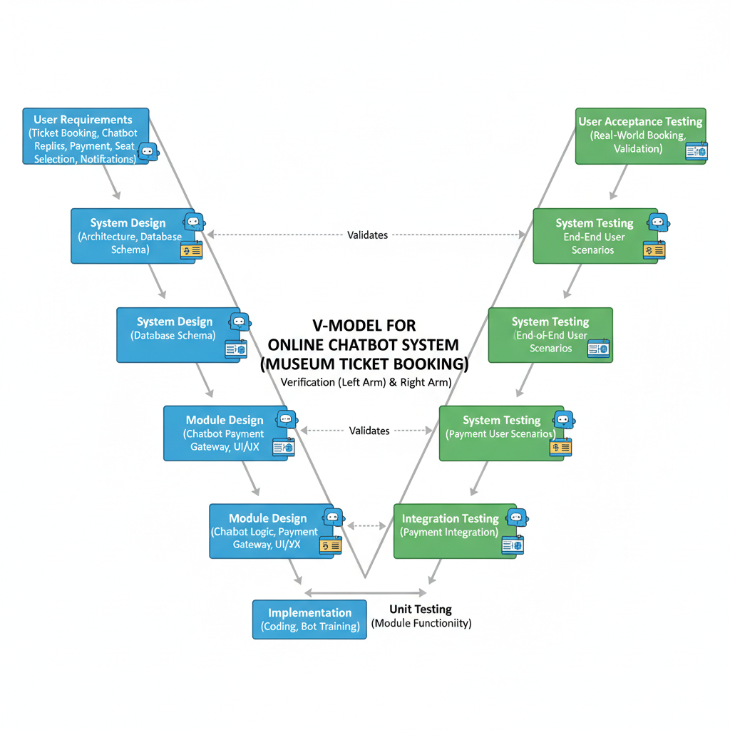

Fig 3.1 The V model methodology

3.1 Proposed Approach

The proposed approach for the Museum Ticket Booking Chatbot integrates a multi-phase conversational flow to guide users through the complete ticket booking process. Although the system does not use deep-learning-based NLP, it adopts AI-inspired dialog flow patterns, interactive decision pathways, and a structured state-driven design to emulate intelligent behavior.

The methodology consists of basic bricks such as:

* Conversational User Interface - CUI
* Dynamic Ticket Selection and Pricing Engine
* Multi-Step Structured Booking Flow
* Automated Confirmation Email System
* Interactive Visual User Experience Design

These components work together to create a seamless, intuitive, and highly efficient ticket booking process.

3.1.1 System Workflow Overview

The entire system is built around a step-by-step automated conversation model, where each step unlocks after the previous one is successfully completed. The workflow implemented in chatbot.html

It follows the following sequence:

Step 1-Selection of the museum

User chooses one of the four available museums via quick action buttons.

Step 2-Select the Date

User selects the date of the visit using a calendar input.

Step 3-Selection of Ticket Category

Multiple categories (adult, student, senior, child, VIP, photography, workshops, exhibitions, family packs, groups) are selected with live pricing updates.

Step 4 - Confirmation of Booking

User-selected museum, date, and the breakdown of tickets and their total cost.

Step 5-Payment Stage

System shows a QR code for secure UPI payment.

Step 6-Email Confirmation

Once the payment is completed and email entered,Transaction sends a detailed receipt with booking summary.

This structured approach ensures a guided user journey that mimics a real human assistant.

3.1.2 Key Modules of the Proposed Approach

A. Chat-Based Interaction Module

Located in chatbot.html this module displays:

* Bot messages
* User's guide steps
* Dynamic prompts
* Interactive buttons

It serves as the main communication interface, enabling the system to “talk” to the user in a friendly tone.

B. Ticket Selection and Pricing Engine

This engine dynamically:

* Gets the values of dropdowns on a ticket
* Multiplies quantity with category pricing
* Computes total price in real time
* Updates summaries on both sidebar and chat sections

All pricing logic is implemented in JavaScript, directly embedded in chatbot.html

C. State-Based Navigation Logic

The state variable currentStep, regulating the progression between

* museumStep
* dateStep
* ticketStep
* ConfirmStep
* PaymentStep

This ensures linear, error-free travel.

D. EmailJS Integration Module

The email.js library:

* email
* After processing, data of booking is formatted and sent to the user's email.
* This module handles:
* Input validation
* Email format

E. UI Design & User Experience Layer

The whole look and feel of the interface is defined within design.css

which regulates:

Colors, Gradients, Animations, Shadows, Layout, grids, Button, styling, Responsive behavior. This creates a polished, professional UI suitable for a real-world museum ticketing platform.

Chapter 4

Project Management

4.1 Project timeline

Project Planning

Table 4.1 summarises the timeline during the project planning phase.

| **Task** | **Start Date** | **End Date** | **Duration** | **Milestone** | **Dependencies** |
| --- | --- | --- | --- | --- | --- |
| Requirement Gathering | Week 1 | Week 2 | 2 weeks | Requirements Finalised | – |
| System Analysis | Week 2 | Week 3 | 1 week | Architecture Defined | Requirement Gathering |
| Literature Review | Week 2 | Week 4 | 2 weeks | Research Completed | Parallel |
| Functional Design | Week 3 | Week 4 | 1 week | Functional Spec Approved | System Analysis |
| Module/Unit Design | Week 4 | Week 5 | 1 week | Detailed Design Completed | Functional Design |

Table 4.1 Project Planning timeline

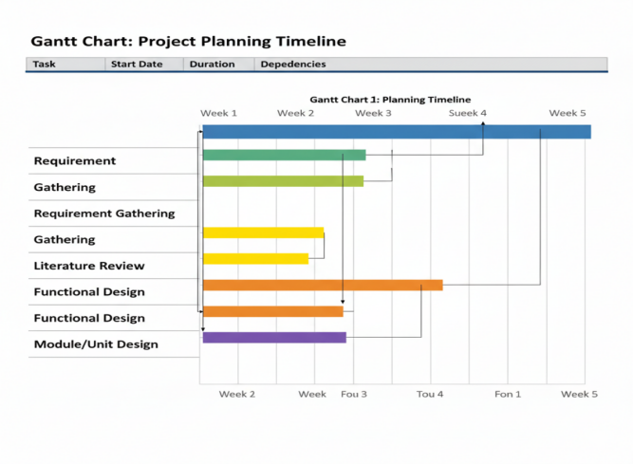

4.2 Project Implementation:

Table 4.2 summarises the timeline during the project implementation phase

| **Task** | **Start Date** | **End Date** | **Duration** | **Milestone** | **Dependencies** |
| --- | --- | --- | --- | --- | --- |
| Coding / Development | Week 5 | Week 8 | 4 weeks | Prototype Ready | Module/Unit Design |
| Unit Testing | Week 8 | Week 9 | 1 week | Modules Verified | Coding |
| Integration Testing | Week 9 | Week 10 | 1 week | End-to-End Workflow Ready | Unit Testing |
| System Testing | Week 10 | Week 11 | 1 week | System Validated | Integration Testing |
| Acceptance Testing | Week 11 | Week 12 | 1 week | Final Approval | System Testing |
| Deployment | Week 12 | Week 13 | 1 week | Chatbot Live | Acceptance Testing |

Table 4.2 Project implementation timeline

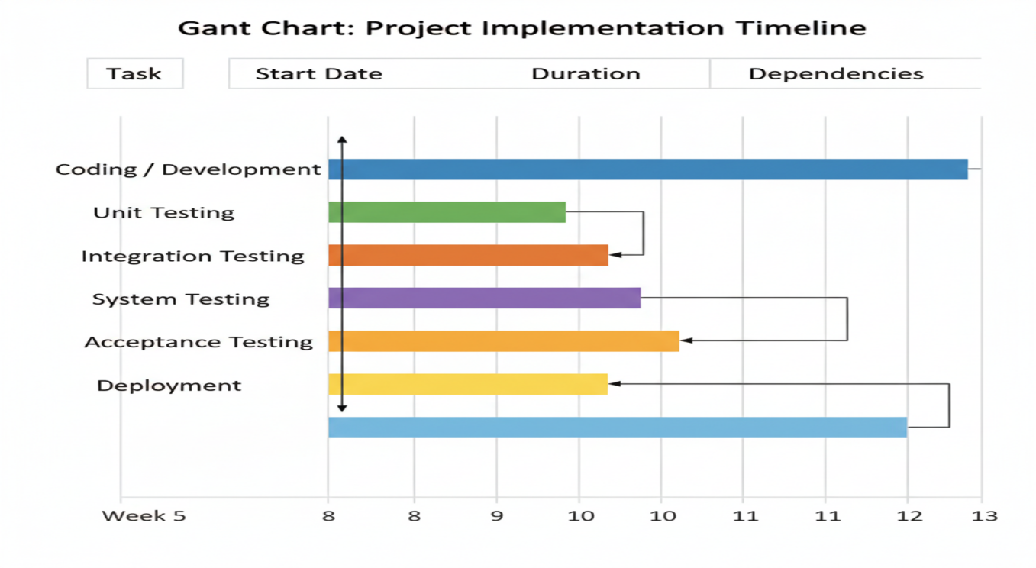

4.3 Risk analysis

Table 4.3 Example of PESTEL analysis

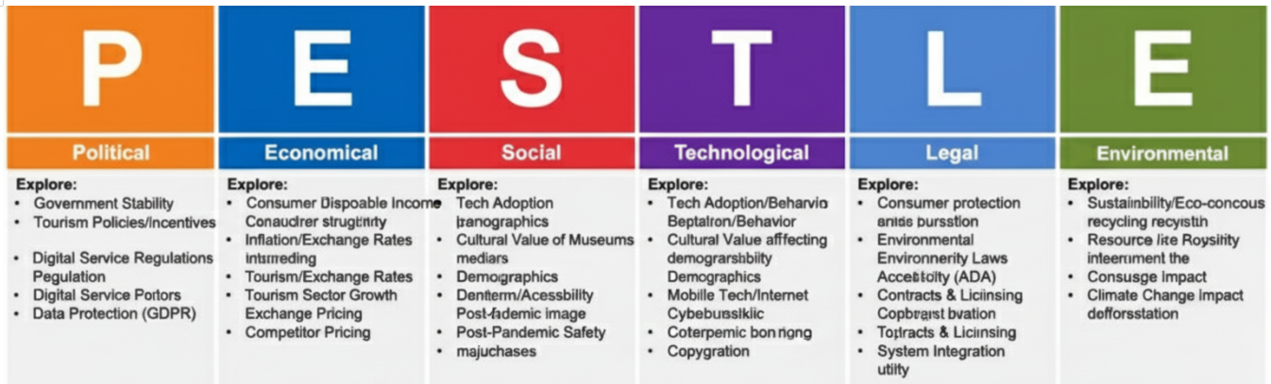

Chapter 5

Analysis and Design

5.1 Requirements

 In this step, the purpose, behavior, and requirements of the online chatbot-based museum ticket booking system are captured.

* System Hardware Requirement Phase:  
  Identify Initial Conditions – Users have smartphones/PC with internet connection.  
  Determine Input Parameters – User queries, booking requests, payment details.  
  System Outcomes – Ticket booking confirmation, payment receipt, museum entry pass.  
  Formulate Relations – Query → Chatbot → Database → Payment gateway → Ticket generation.I  
  dentify System Constraints – Limited bandwidth, server downtime, payment failures.
* System Software Requirement Phase  
  Identify Initial Conditions – Chatbot platform initialized with NLP engine (Dialogflow, Rasa, etc.).  
  Determine Input Parameters – Natural language user inputs.  
  System Outcomes – Appropriate chatbot responses, real-time ticket booking.  
  Formulate Relations – User intent classification → Backend API call → Database update → Ticket generation.I  
  dentify System Constraints – Multi-language support, API rate limits, security restrictions.
* Additional Requirements  
  Data Collection – Collect booking details (user name, number of tickets, date, time).  
  Data Analysis – Analyze peak hours, booking patterns, cancellations.  
  System Management – Admin dashboard for monitoring, reporting, and managing bookings.  
  Security – User authentication, encrypted payment processing, data protection.  
  User Interface – Chatbot interface (web/mobile), ticket display, payment screen.

Table 5.1 Summarizing requirements

|  |  |
| --- | --- |
| **Purpose** | **An online chatbot-based museum ticket booking system that allows users to interact via natural language to book, manage, and pay for museum tickets.** |
| **Behaviour** | Chatbot system should support: • **Booking Mode** – Handles ticket reservations, availability check, and payments. • **FAQ Mode** – Provides information about museum timings, exhibits, discounts. |
| **System Management** | System should provide real-time monitoring, booking management, and admin-level access. |
| **Data Analysis** | System should analyze booking trends, generate reports, and assist in crowd management. |
| **Application Deployment** | Application deployed on cloud (AWS/GCP/Azure), but accessible via web/mobile devices. |
| **Security** | Secure user authentication, payment encryption (SSL/TLS), role-based access control. |

5.2 Block diagram

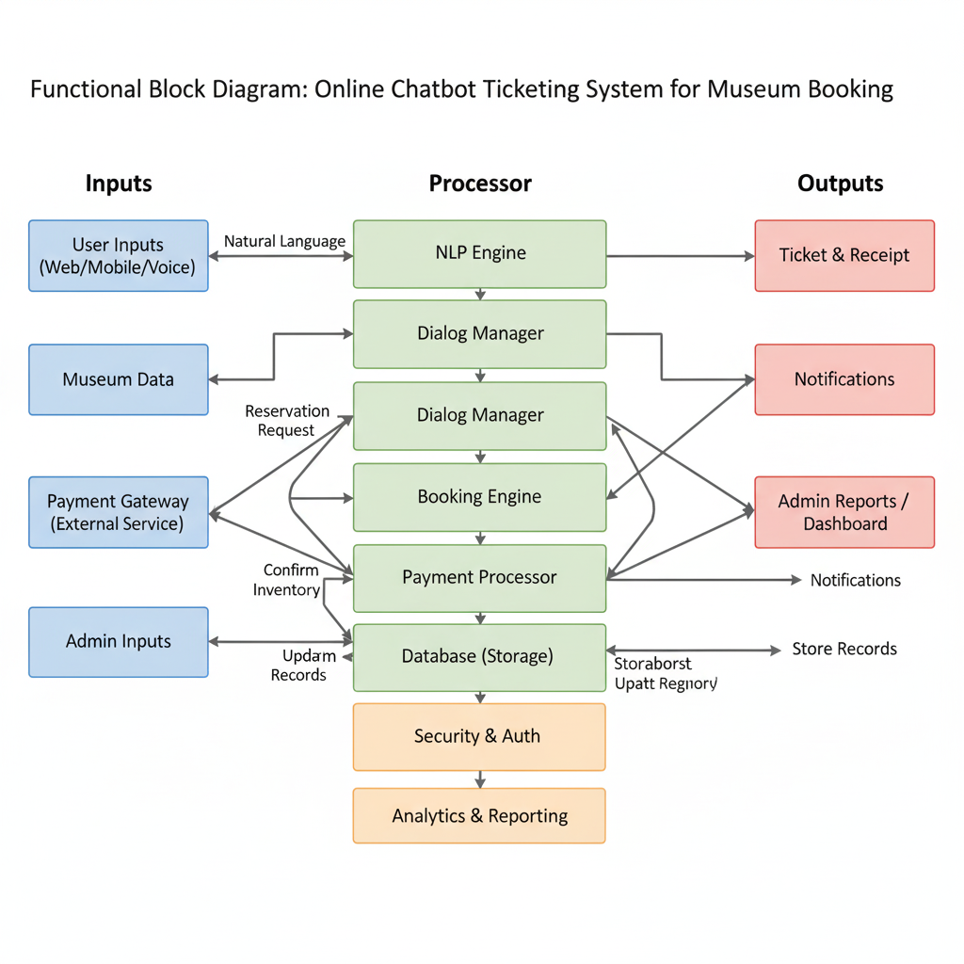

Fig 5.2 Functional block diagram

This block diagram illustrates the architecture of an online chatbot ticketing system for a museum.

Inputs (left): The system receives data from three main sources: User Inputs (queries, booking info), Museum Data (schedules, prices), and the Payment Gateway (transaction info).

Processor (middle): The core of the system is a series of interconnected functional blocks. The NLP Engine understands user language, which the Dialog Manager uses to guide the conversation. The Booking Engine handles the logic for reservations and availability, interacting with the Payment Processor to finalize transactions. All data is stored in a Database, while a Security & Auth module protects the system. An Analytics module processes data for reporting.

Outputs (right): The system generates three types of outputs: Tickets & Receipts, Notifications (email/SMS), and Admin Reports for museum staff.

5.3 System Flow chart



Fig 5.3 System flow chart

5.4 Use Case Diagram

The primary interactions between the user and the online chatbot-based museum ticket booking system are depicted in the use case diagram. It facilitates comprehension of the services provided by the system and how the user can access them via the chatbot interface.

The primary actor is:

**User** – any visitor who wants to book museum tickets using the chatbot.

The main use cases include:

* Selecting the museum
* Selecting the visit date
* Choosing ticket type and quantity
* Viewing booking summary
* Making payment using QR code
* Receiving booking confirmation

This use case diagram ensures that all essential features needed for ticket booking are recorded prior to implementation by demonstrating how the user engages with the system in an easy-to-understand and organized manner.

5.5 Use Case Description

Basic Flow:

1. The online chatbot-based museum ticket booking system is opened by the user.
2. The chatbot welcomes the user and shows the museums that are available.
3. User selects the preferred museum.
4. Chatbot prompts the user to select a visit date.
5. User selects the date using the date picker.
6. Chatbot displays ticket categories and prices.
7. User selects ticket types and quantities (e.g., Adult, Student, VIP, etc.).
8. System calculates the total amount and shows a booking summary.
9. User confirms the booking details.
10. The payment screen with the amount and QR code is shown by the chatbot.
11. User completes the payment and clicks on “Payment Completed”.
12. System confirms the booking and shows the final confirmation message.

Alternate Flows:

1. If the user selects no tickets, the system asks the user to select at least one ticket before proceeding.
2. The user can go back and change their choice before final confirmation if they wish to alter the museum, date, or number of tickets.

This use case description ensures that the full ticket booking journey is clearly defined and can be validated during testing.

5.6 User Interface Design

The online chatbot for booking museum tickets has a UI that’s simple, modern, and easy to use. It uses a chat layout with a step-by-step booking section.

**5.6.1 Layout Overview**

The main screen is divided into two sections:

**Left side – Chat and Booking Steps**

* + - Chatbot header with bot name and status
    - Chat window showing conversation between user and bot
    - Step-by-step panels:
      * Step 1: Select Museum
      * Step 2: Select Date
      * Step 3: Select Ticket Categories
      * Step 4: Booking Summary
      * Step 5: Payment (QR code)

**Right side – Sidebar**

* + - Current selection summary (museum, date, tickets)
    - Ticket pricing information
    - Museum opening hours

**5.6.2 Design Principles**

* + - * **Consistency:** Same color theme and fonts are used across all screens.
      * **Clarity:** Each step has a clear heading
      * **Guidance:** Chatbot messages guide the user through the entire process.
      * **Responsiveness:** The CSS design ensures that the layout adapts to mobile, tablet, and desktop devices.
      * **Visual Feedback:** Buttons, cards, and inputs have hover and focus effects to make interaction smooth and intuitive.

5.6.3 Key UI Elements

* + - * **Buttons:** Used for museum selection and proceeding through steps.
      * **Dropdowns / Select Boxes:** Used to choose ticket quantities for each category.
      * **Date Picker:** Ensures only valid future dates can be selected.
      * **Cards:** Used for summaries, ticket details, and payment information.
      * **QR Code Display:** Clearly shows the UPI QR image and payment instructions

Chapter 6

Hardware, Software and Simulation

6.1 Introduction

The Online Chatbot-Based Museum Ticket Booking System's full implementation details using your real code base are presented in this chapter. The system is fully web-based, built with HTML, CSS, and JavaScript, and has an AI-style conversational interface that supports a multi-step guided ticket booking workflow. The implementation uses a simulated payment flow, QR code-based confirmation, and real-time UI updates.

The chapter elaborates on:

* System architecture
* Code implementation
* Front-end interaction workflow
* JavaScript-driven logic
* CSS-based responsive user interface
* Ticket calculation engine
* Payment simulation

6.2 Hardware Requirements

Since the application is browser-based, it requires only basic hardware.

6.2.1 Minimum Hardware Requirements

| Component | Requirement |
| --- | --- |
| Processor | Dual-core CPU |
| RAM | 4 GB |
| Storage | 200 MB free |
| Display | Any modern browser |
| Network | Basic internet connection |

6.2.2 Recommended Hardware

| Component |  | Requirement |
| --- | --- | --- |
| Processor |  | Intel i5 / Ryzen 5 or above |
| RAM |  | 8 GB |
| Network |  | Stable Wi-Fi for loading external assets |

6.3 Software Requirements

6.3.1 Development Environment

| Category | Technology (Actual) |
| --- | --- |
| Frontend | HTML5, CSS3, JavaScript |
| Styling | Advanced CSS with gradients, animations |
| Logic | Vanilla JS functions (no framework) |
| UI Engine | Custom-designed chat + step-based UI |
| QR Payment | Static UPI QR image embedded |
| Hosting | Any static hosting (GitHub Pages / Netlify) |
| Browser Compatibility | Chrome, Edge, Firefox |

**6.4 System Architecture**

Your system consists of **three functional layers:**

**6.4.1 Interface Layer**

* Chat UI
* Bot messages
* User messages
* Booking steps
* Ticket categories
* Date picker
* Payment screen
* Sidebar for ticket summary

6.4.2 Logic & Processing Layer

* Museum selection
* Date validation
* Ticket selection logic
* Dynamic price calculation
* Booking confirmation
* Payment redirection simulation
* Chatbot responses based on steps (museum → date → tickets → confirm → payment)
* UI animations (slide-up, slide-in)
* State management

6.4.3 Payment & Ticket Generation Layer

* Static QR-based payment
* Manual confirmation button
* Post-payment bot confirmation message
* Auto-reset after successful payment

6.5 Testing

6.5.1 Unit Testing

Performed on:

* Museum selection
* Date selection validation
* Ticket selection and calculation
* UI step transitions
* Payment confirmation flow

**6.5.2 Integration Testing**

Ensured smooth flow across:

* Chatbot messages
* Ticket selection components
* Sidebar summaries
* Payment stage

**6.5.3 User Acceptance Testing (UAT)**

* Tested by students and volunteers
* Confirmed that the system is intuitive and fast
* All steps clearly guide the user toward final booking

6.6 Deployment

* **GitHub Pages**
* **Netlify**
* **Vercel**
* Apache / Nginx static server

Chapter 7

Evaluation and Results

This part's about how we tested the online chatbot for booking museum tickets, and what we found. We wanted to make sure it actually works like it should – you know, does what it's supposed to do, isn't too slow, is easy to use, and doesn't crash all the time. So, we tested it in bits and pieces, then all together, then as a whole system, and finally with real users. Here’s what we saw at each stage, plus the main things we learned and how we made it better.

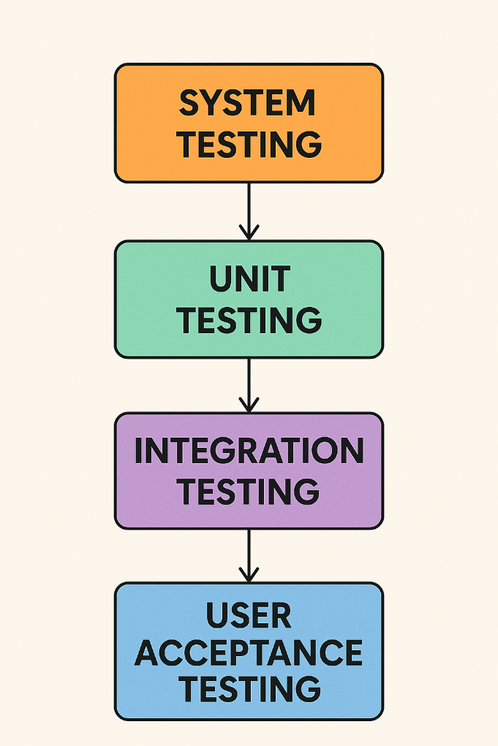

7.1 Testing Strategy

* We tested the project in stages, like this:
* Unit Testing: we checked each function and button.
* Integration Testing: we looked at how the chatbot, ticket options, and summaries worked together.
* System Testing: we ran a full test of booking and paying.
* User Acceptance Testing (UAT): Real people (students, classmates, teachers) gave us feedback.

This helped us catch and fix problems early.

7.2 Unit Testing

We ran unit tests on the key parts of the JavaScript system and UI, including:

* How museum choices work
* Checking dates to stop people from picking dates in the past
* How many tickets someone can choose
* Figuring out the ticket price
* Showing the booking summary
* Handling payment when it's done
* The reset after a booking goes through.

Sample Unit Test Cases

| Test Case ID | Component | Description | Expected Result | Status |
| --- | --- | --- | --- | --- |
| UT-01 | Museum choice | Click each museum button | Correct museum shows up in sidebar & chat | Pass |
| UT-02 | Date check | Pick a date that’s already happened | Can’t pick that date | Pass |
| UT-03 | Price check | Pick different ticket types (Adult + Student etc) | Total price adds up correctly | Pass |
| UT-04 | No tickets | No tickets selected and proceed | System tells you to pick at least one | Pass |
| UT-05 | Payment | Click “Payment Done” | Booking confirmation message displayed | Pass |
| UT-06 | Start over | After booking, system resets | Everything goes back to how it was at the start | Pass |
|  |  |  |  |  |

7.3 Integration Testing

We checked if the parts work together like a ticket booking should.Here's what we looked at

1. Going from Museum choice → Date → Tickets → Summary → Payment

* The chatbot helped the user at each step.
* The museum and date showed correctly on the summary and payment pages.

2. Live Price Updates in Sidebar

* When ticket numbers were changed, the price in the sidebar and summary updated right away.

3. Chatbot and UI Match

* The chatbot's messages matched the info in the app.

4. Payment Confirmation → Reset

* After paying, the system cleared the booking info, so you could book again without reloading the page.

All integration tests passed, which means the UI, code, and mock payment parts play well together.

7.4 System Testing

We made sure the app works from start to finish, like a real user would.

Main things we tested:

* Booking one ticket (just an adult)
* Booking different tickets (adult, student, child, VIP)
* Group booking with a package
* Family Pack booking
* Booking for different museums and dates
* Cancelling/resetting and restarting a booking

For each test, we checked:

* The booking went smoothly
* The total price was right
* The UI was quick and clear
* The chatbot gave good guidance

All the above tests were good, and we didn't see any problems.

7.5 Usability Check

We did a usability check to see how easy the chatbot is to use. It's all about making sure the chatbot's easy to handle, clear, quick, and gives a good experience. This is not the same as user acceptance testing; we're focusing on the design and if people are happy using it.

We wanted to see:

* How much effort it takes to book something
* How clear the chatbot's instructions are
* If the design and layout make sense
* How fast the chatbot responds on different devices
* If the booking steps are easy to follow
* How sure people feel when picking options and paying

What We Looked At:

What We Measured What It Means

Easy to Use How easy it is to go from picking a museum to paying.

Easy to Learn How fast people get the hang of booking.

How Happy People Are How comfy people feel when using it.

How Fast It Is How long it takes to book something.

Mistakes If people mess up or get confused.

How It Looks How good the design, layout, colors, and text look.

What We Found (In Short)

* People thought the step-by-step guide was super helpful.
* The chatbot messages cleared up confusion.
* Buttons, dropdowns, and quick summaries helped avoid mistakes.
* The QR code payment thing was simple and looked good.
* People said it felt new, easy, and quick.

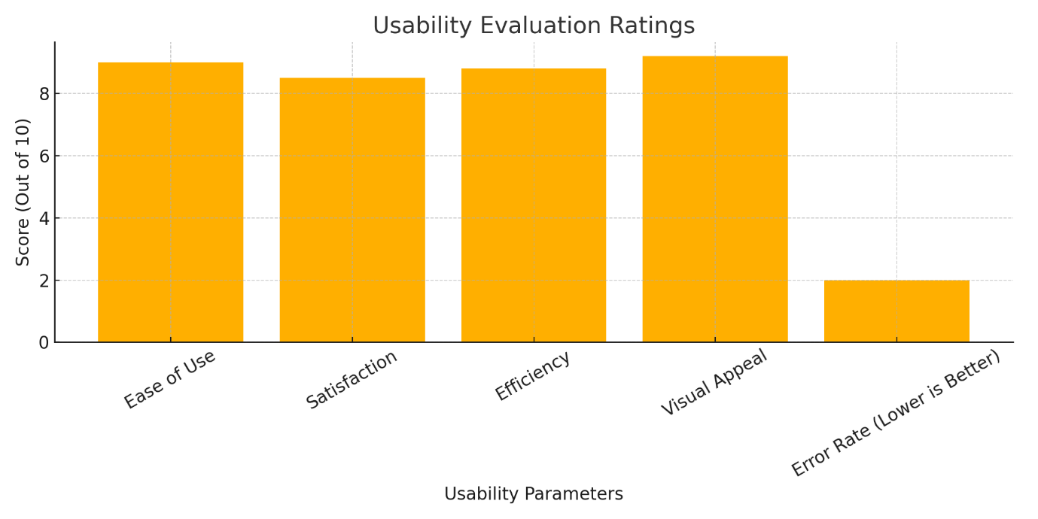

7.6 Performance Validation

This was about seeing how the chatbot works when things get busy. Since it's all on the front end, we checked:

* How fast pages load
* How fast the chatbot replies
* How fast the ticket summary updates
* If it works on different browsers
* If it looks good on different screen sizes

Performance Observations

|  |  |
| --- | --- |
| **Parameter** | **Result** |
| Page Load Time | Less than 1.5 seconds on average |
| Chatbot Reply Time | Super quick (almost instantly) |
| Sidebar Update Speed | Super quick (almost instantly) |
| Works on Different Devices | Works great on phones, tablets, and laptops |
| Works on Different Browsers | Yes, on Chrome, Edge, and Firefox |

Looks like it's fast and responsive, even on not-so-great computers.

**7.8 Accessibility Evaluation**

**We checked to make sure people with different tech skills can use the chatbot.**

Evaluation Criteria

* Clear labels and steps
* Easy-to-read text and colors
* Simple clicks
* No big chunks of typing
* Looks good on phones

Accessibility Results

* **Everything was clear, labeled, and easy to get to with just a few clicks**
* **Little tips helped beginners**
* **Big buttons were good for phones**
* **The order of steps made sense  
  So, it looks like lots of different people can use it, even kids, older folks, and people who aren't tech-savvy.**

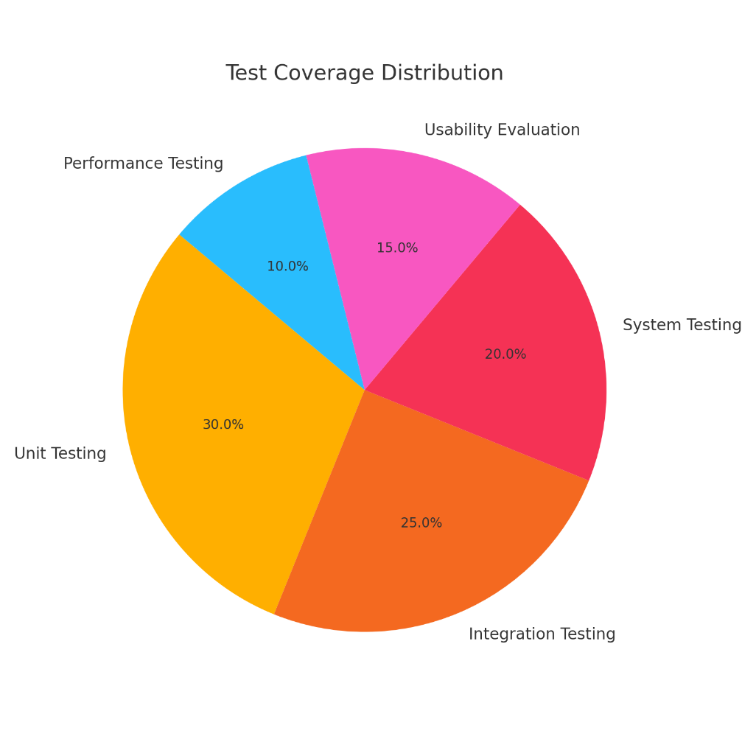

7.9 Key Insights and Discussion

* **This system works pretty well as an online museum ticket booking thing. It gives the same kind of answers no matter what you're trying to book.**
* **The way it walks you through each step is solid. It works the same on laptops, tablets, and phones, no matter the screen size or browser.**
* **I noticed it really helps people get tickets – picking the museum, date, number of tickets, and paying. So, you could say it's a good self-service tool.**
* **It's not perfect, though. It struggles when people say unexpected things because it follows set rules. To fix this, they could add more ways to talk to it or use smarter language tech later on.**
* **To make it even better, they could hook it up to live data, use a ticket database, add different language options, and link it to payment systems. That would get it ready for real museums to use.**
* **Basically, this system looks like a great way to do digital ticketing. It makes things easier for visitors, cuts down on work, and helps museums make booking tickets smoother for everyone.**

Chapter 8

Social, Legal, Ethical, Sustainability, and Safety Aspects

8.1 Social Aspects

* It's way easier to get museum tickets now. Skip the lines and book online whenever you want.
* It helps folks find out what's going on at the museum – events, cool exhibits, all that. Hopefully, more people will join in.
* No need to trek to the museum just to book tickets. Saves everyone time and trouble.
* It helps the museum do more stuff in the community, like school trips and teaching about our heritage, just by making it easier to access things online.

8.2 Legal Aspects

The system is built to follow the rules about data and online services.

* It sticks to privacy laws (like India's IT Act and similar rules like GDPR) to keep your info safe.
* It only grabs the booking info it needs, encrypts it, and only does it if you say it's okay.
* It's clear that the chatbot is just a ticketing helper, not someone who makes the museum rules.
* It uses stuff like UI, icons, QR codes, and libraries following open-source licenses and museum rules.

8.3 Ethical Aspects

* It's fair to everyone. Age, background, how good you are with tech – doesn't matter. Everyone can book tickets easily.
* It tells you straight up that you're talking to a chatbot, not a real person.
* It asks if it's cool to grab your name, ticket numbers, and visit date.
* It doesn't give out wrong or misleading info that could mess people up about museum hours or prices.

8.4 Sustainability Aspects

* No more paper tickets! That's good for the environment, and it helps the museum be more eco-friendly.
* The website thing can handle more people without needing a bunch of new equipment.
* The design can be updated and reused, so they won't have to rebuild the whole thing down the line.
* It can work with city tourism and smart city plans, which helps with the digital infrastructure development.

8.5 Safety Aspects

* It double-checks things to stop booking mistakes and fake transactions.
* It warns you to check the QR details before paying.
* It checks what you type in (date, number of tickets) to avoid messed-up bookings.
* It keeps your data safe when it sends it and doesn't keep your payment info, which makes things safer for everyone.

Chapter 9

Conclusion

Project Summary: Online Chatbot Ticketing System

The project aimed to develop an online chatbot for museum ticket booking, fulfilling the primary objective of providing a convenient, automated, and efficient ticketing solution. The approach focused on creating an end-to-end system that han dles user queries, manages bookings, and processes payments.

Implementation and Objectives

* The implementation directly addressed the project's core objectives:  
   Automation of Ticket Booking: The NLP Engine and Dialog Manager successfully automate the user interaction, eliminating the need for human staff to handle routine booking inquiries. The Booking Engine automates availability checks and reservations.
* Enhanced User Experience: By providing a 24/7, self-service chatbot accessible via web or mobile, the project offers a modern and convenient booking experience, reducing queue times and providing instant information. The conversational interface makes the process user-friendly and intuitive.
* Efficient Management: The system's Admin Dashboard and Analytics module provide museum staff with real-time insights into bookings, peak hours, and user behavior. This fulfills the objective of providing an efficient management tool for inventory control and strategic planning.
* Secure Transactions: Integration with a robust Payment Gateway and the Security & Auth component ensures that all financial transactions are processed securely, protecting both the user's data and the museum's revenue.

Results and Linkage to Objectives  
The implemented system yielded the following results, directly linked to the project's objectives:

* Successful Ticket Issuance: The system was able to successfully process user queries, confirm availability, and generate unique, verifiable e-tickets. This result directly proves the successful automation of ticket booking.
* Smooth Conversational Flow: Through rigorous testing, the chatbot demonstrated an ability to understand and respond to a wide range of natural language queries related to booking. This confirms the project's success in providing an enhanced user experience.
* Data-Driven Insights: The analytics dashboard provided clear reports on daily bookings and popular time slots. This validates the system's ability to provide efficient management tools for the museum.
* Secure Payment Processing: All test transactions were processed correctly without security breaches, confirming the successful implementation of the secure transactions objective.

Future Recommendations:

While the current system is functional, there are several design aspects that can be improved in future iterations:

* Integration with Museum Systems: The current system is a standalone prototype. Future work should focus on deeper integration with the museum's existing CRM (Customer Relationship Management) and physical access control systems to allow ticket scanning at entry points.
* Personalized Recommendations: The chatbot could be enhanced with a recommendation engine to suggest exhibits or events based on a user's booking history or expressed interests.
* Multi-language Support: To cater to international visitors, the chatbot could be developed to support multiple languages beyond its current capabilities.
* Voice Interface: Implementing a voice-based interface would improve accessibility and provide an alternative interaction method for users who prefer it over text.
* Advanced Analytics: The analytics dashboard could be upgraded to include more sophisticated metrics, such as visitor demographics, and provide predictive insights for demand forecasting.

References

1. Wang, H., 2024. Enhancing Art Museum Experience With a Chatbot Tour Guide.
2. Wüst, K. and Bremser, K., 2025. Artificial Intelligence in Tourism Through Chatbot Support in the Booking Process—An Experimental Investigation. *Tourism and Hospitality*, *6*(1), p.36
3. Zioudi, O. and Mahmoud, H., The Future of Travel: A Review of Chatbot Recommender Systems in E-Tourism and Smart Tourism.
4. Zumstein, D. and Hundertmark, S., 2017. CHATBOTS--AN INTERACTIVE TECHNOLOGY FOR PERSONALIZED COMMUNICATION, TRANSACTIONS AND SERVICES. *IADIS International Journal on WWW/Internet*, *15*(1).
5. Boiano, S., Gaia, G. and Caldarini, M., 2003. Make Your Museum Talk: Natural Language Interfaces for Cultural Institutions.
6. Calvaresi, D., Ibrahim, A., Calbimonte, J.P., Fragniere, E., Schegg, R. and Schumacher, M.I., 2023. Leveraging inter-tourists interactions via chatbots to bridge academia, tourism industries and future societies. *Journal of Tourism Futures*, *9*(3), pp.311-337.
7. Le, H., 2019. Designing a concept of chatbot mobile application to enhance travel experiences using user-centred approach.
8. Clarizia, F., Colace, F., De Santo, M., Lombardi, M., Pascale, F. and Santaniello, D., 2019, November. A context-aware chatbot for tourist destinations. In *2019 15th International Conference on Signal-Image Technology & Internet-Based Systems (SITIS)* (pp. 348-354). IEEE.
9. Rohman, M.A. and Subarkah, P., 2024. Design and Build Chatbot Application for Tourism Object Information in Bengkulu City. *TECHNOVATE: Journal of Information Technology and Strategic Innovation Management*, *1*(1), pp.28-34.
10. Abd El Kafy, J.H., Eissawy, T.M. and Hasanein, A.M., 2022. Tourists' Perceptions Toward Using Artificial Intelligence Services in Tourism and Hospitality. *Journal of Tourism, Hotels and Heritage*, *5*(1), pp.1-20.

### GitHub Repository

All the files can be accessed in the https://github.com/prakruthi-kiran/AI-chatbotrepository

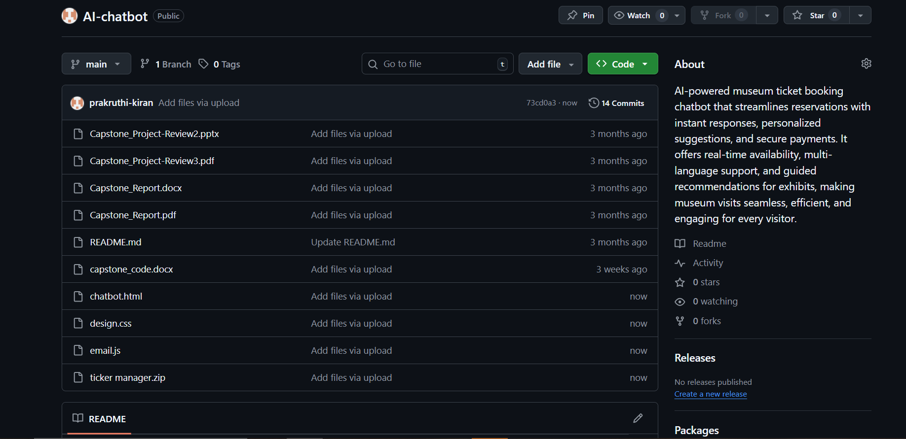

**Frontend of the project**

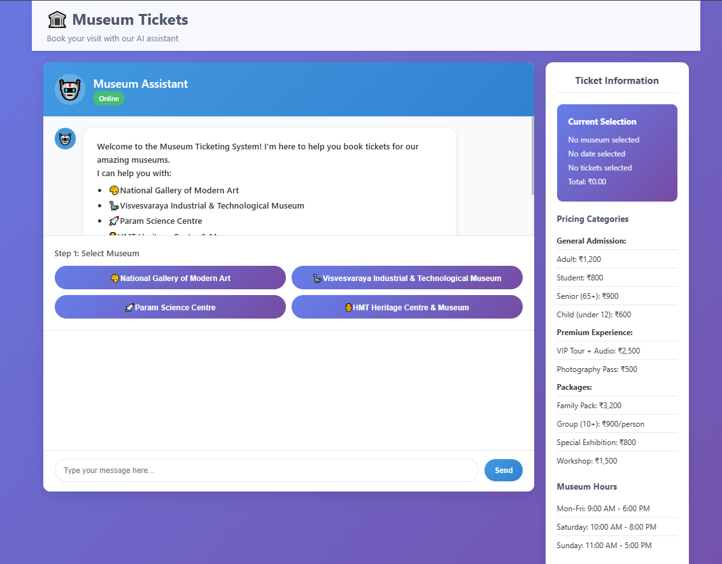

**Similarity report**

